The Access application is executed after the Magento export file has been imported. Steps to import this file are discussed in another document contained on the Special Applications tab. After importing this file, the application processes the file based on the following menu commands (You may use the zoom feature in the lower right section of your screen to improve the readability of these reports):
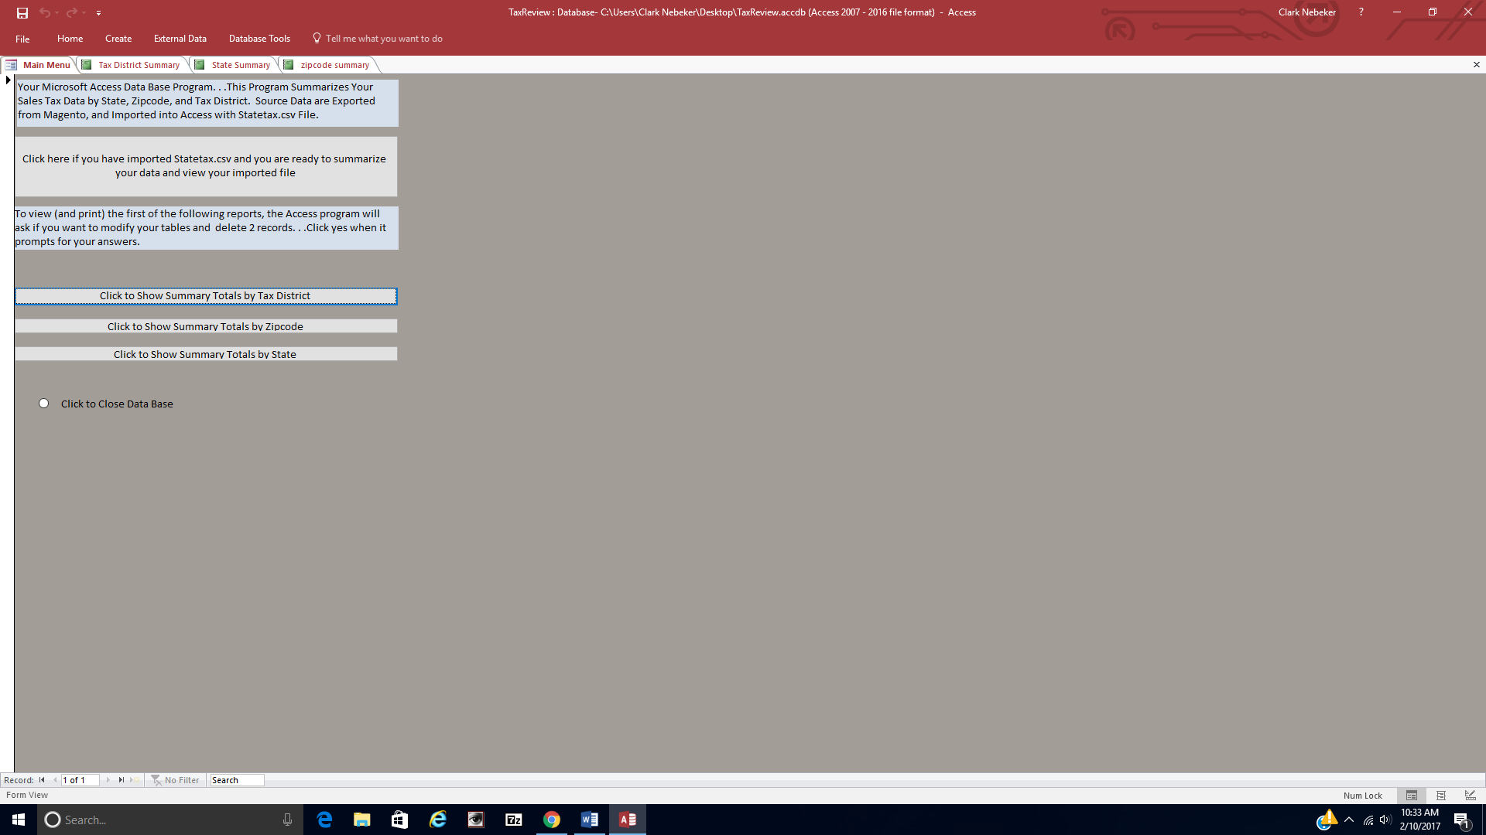
The Access data base application produces three reports that summarize data for the Magento export file. Reports show summaries by state, zip code and tax location. The following are summaries produced from the sample import (Magento export) file which is available on the Special Applications tab.

Summary by state:
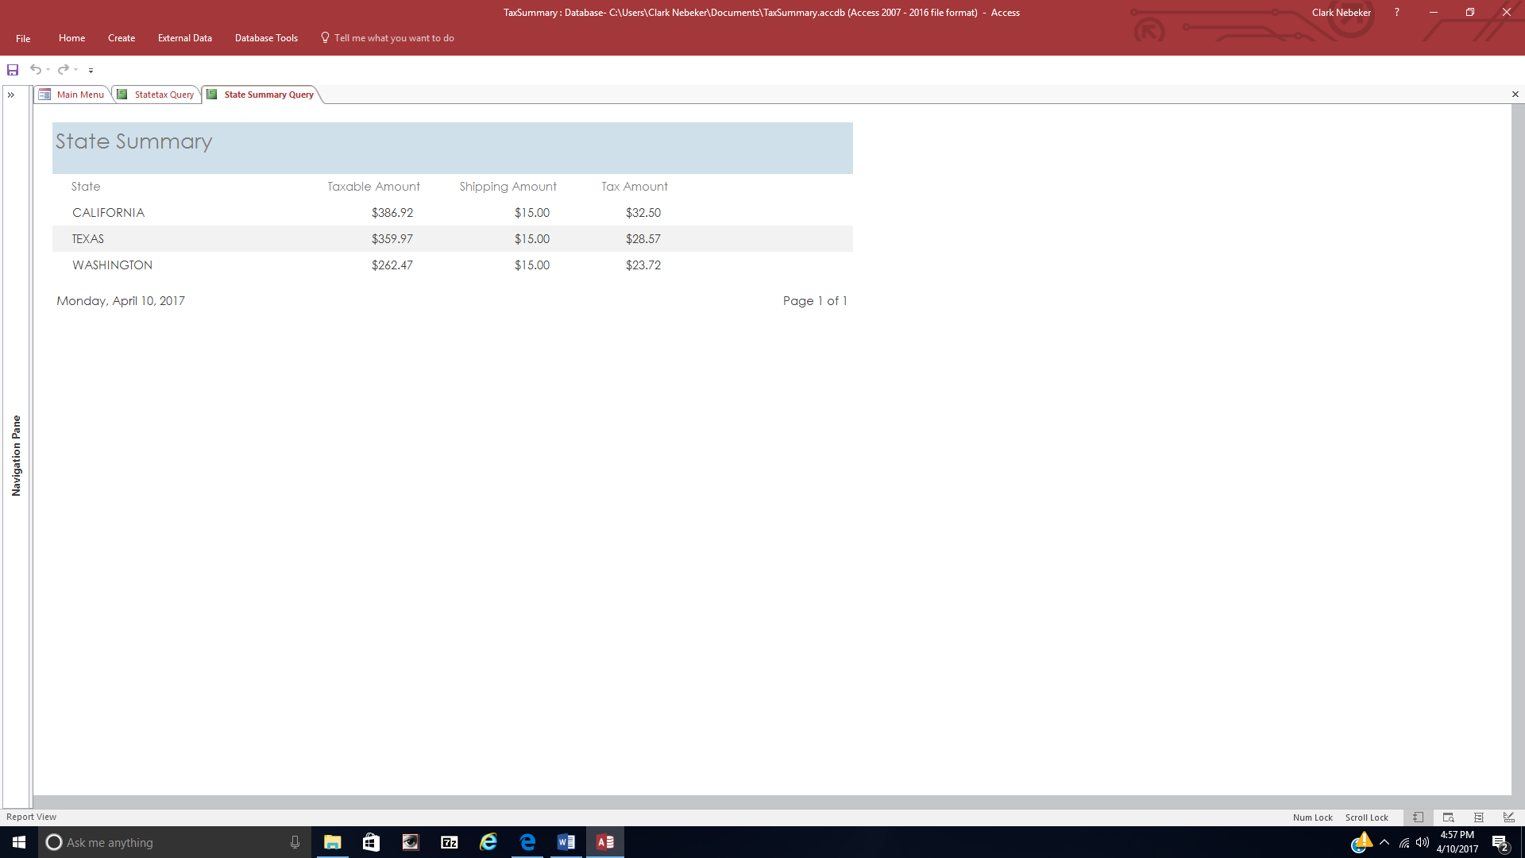

Summary by zip code:
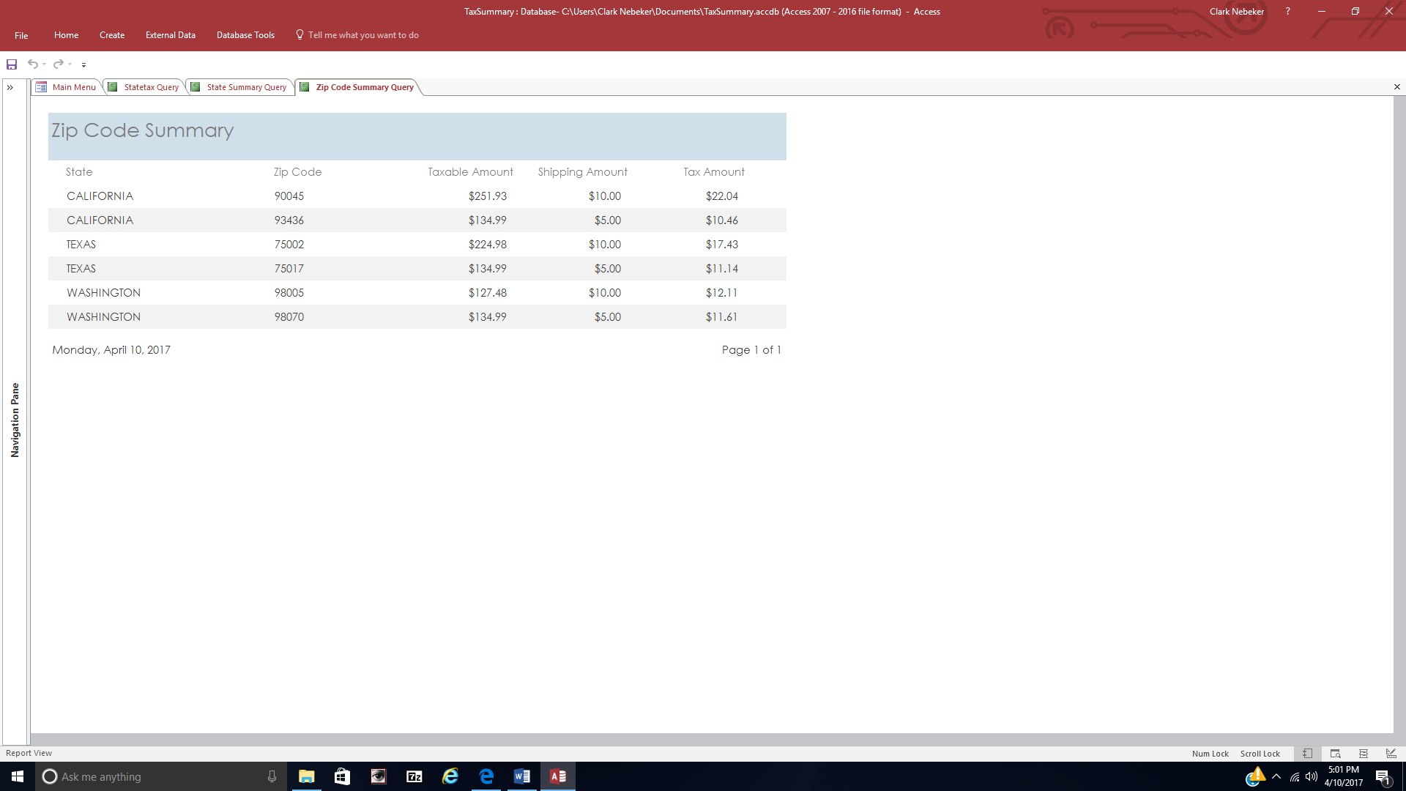

Summary by tax location:
