TaxCompliant Magento Advance Extension
This ReadMe document shows the step-by-step process for installing the TaxCompliant Advance Extension. Following installation, steps to Configure the extension are discussed. Finally, steps for Disabling the TaxCompliant Extension are discussed.
Installation
Follow the following steps:
Step 1: Download the TaxCompliant_Advance_Extension from the TaxCompliant.net web site.
Step 2: Unzip or “Extract” the downloaded files.
Step 3: Connect to your Magento store system files through an ftp application, such as FileZilla.
Step 4: Copy the App folder (in the extracted files) to the Root folder of your Magento store.
Step 5: Once the App folder is copied, the extension is essentially installed. However before using the extension, it will be necessary to clear the Cache of the Magento store.
Step 6: To clear the Cache, login to the Magento Store admin. Go to System/Cache Management.
Do the following:
- Flush Magento Cache
- Flush Cache Storage
- Flush Catalog Images Cache
- Flush JavaScript/CSS Cache
After flushing out the cache, under “Cache Storage Management”, press “Select All” and press “Submit”. Make sure the Action has “Refresh” set.
To verify that the extension is installed, and to configure it for your store, go to System/Configuration/TaxCompliant/TaxCompliant Advance:
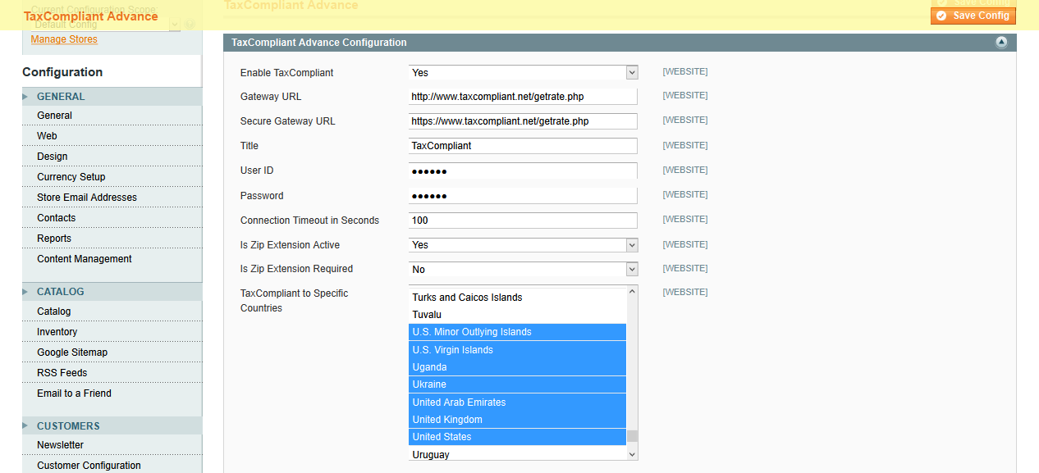
(*** Please don’t attempt to configure your store until you have received confirmation from TaxCompliant.net that your registration has been received and your User Id and Password have been recorded. With this confirmation, you may enter them on this screen along with the other configuration data.)

Enable TaxCompliant: Enable this functionality for web store.
Gateway URL: Link for the API (URL) to obtain tax data from TaxCompliant.net.
Secure Gateway URL: Link for the API (URL) to obtain tax data from TaxCompliant.net.
User ID: User ID, as specified on the TaxCompliant registration form.
Password: Password, as specified on the TaxCompliant registration form.
Connection Timeout in Seconds: Module will try to connect the TaxCompliant server in number of seconds.
Is Zip Extension Active: Enter “Yes” (must be specified).
Is Zip Extension Required: Enter “No” (must be specified).
TaxCompliant to Specific Countries: You can enable this module functionality from selected countries but currently it’s only for the United States.

Configuration:
The Tax Class should be the same as the Product Tax Class (“Taxable Goods”). Select this Tax Class by going to System/Configuration/Tax/Tax Classes and selecting the appropriate Class for Shipping.

Disabling the TaxCompliant Extension:
Go to following file in the Magento store: app\etc.\modules\TaxCompliant_Advance.xml.
Update <active>true</active> to <active>false</active> to disable the component.

